**A142**-Eur-Czech Republic-Petrkovice-**Figurine-Anthropomorphic-Female-Abstract-Hematite-**20,790 BP

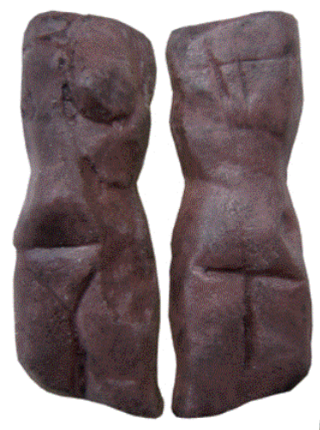 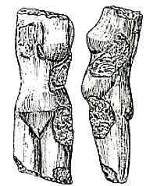

Fig. 1. Czech Republic-Petrkovice-**Figurine-Anthropomorphic-Female-Abstract-Hematite-**20,790 BP Fig. 2. Drawing of orginal.

**Formal Label:** Czech Republic-Petrkovice-**Figurine-Anthropomorphic-Female-Abstract-Hematite-**20,790 BP **+/-** 270 BP

**Display Description:** This headless female figurine of mammoth ivory from the eastern Gravettian Culture is associated with open sites of specialized mammoth hunters on the plains of central Europe and Russia such as the derivative Pavlovian culture, in the region of Moravia, northern Austria, the Czech Republic and southern Poland ca 29,000 – 22,000 BP. Two indications of female gender are the pubic “V” and small breasts.

**Accession Number: A 142.**

**LC Classification:** GN772.2.A8.

**Date or Time Horizon:** 20,790 +/- 270 BP

**Geographical Area:** Czech Republic, Moravia, Petrkovice bei Ostrava

**Map, GPS Coordinates**: 49.88464, 18.280184

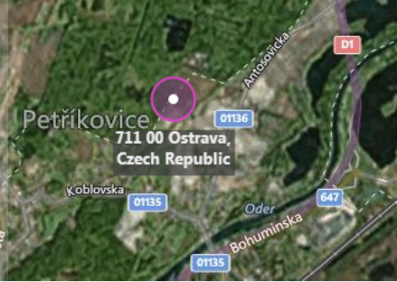

Fig. 3. Map, Czech Republic, Moravia, Petrkovice bei Ostrava. <https://www.bing.com/maps/?v=2&cp=49.835556~18.2925&style=h&lvl=12&sp=Point.49.835556_18.2925_Ostrava___>

**Cultural Affiliation:** eastern Gravettian,

**Medium:** Hematite

**Dimensions: H 4.5 cm; W** 1.5 x 1.4 cm**.  
Weight: original, not known.**

**Provenance: original, Moravian Museum in Brno.**

**Condition:** museum replica in resin.

**Discussion:**

This hematite figurine was found within the current city limits of Ostrava (Ostrava-Petřkovice), Silesia, in the Czech Republic, by archaeologist Bohuslav Klíma on 14 July 1953. It was beneath a mammoth molar at an ancient settlement of mammoth hunters. Many stone artifacts and skeletal fragments were also found nearby. The absence of the head appears to be intentional, and, unlike other obese prehistoric Venus figurines, it shows a slender female, suggesting that its intentionality was personal and not social as a fertility amulet.

The spatial analysis of this Moravian Gravettian landscape can be viewed on four levels (Svoboda 2003):

1. The Gravettian landscape (which differs from the Aurignacian or the Magdalenian landscapes) is related to the riverine network of Moravia, where sites and site-clusters are localized in the valleys, in lower altitudes, and in almost regular distances between each other.
2. The site-clusters (such as Dolní Věstonice-Pavlov) demonstrate an internal hierarchy, based on the size and the complexity of archaeological record.
3. The large sites are separated into individual settlement units (hearths, features, objects).
4. Dwelling structures are classified in four formal types; the hypothetical architectural constructions are tested against analogies from experimental archaeology and ethnoarchaeology.

As a result of this archaeological spatial analysis of the Moravian Gravettian landscape we may suggest that the hematite figurine was implanted in a discrete, individual dwelling within a larger site cluster of dwellings and that hematite was chosen for its obvious weightiness as an object of worth to the sculptor, as there were many local stone sources that could have served the same purpose.

**References:**

Svoboda, Jiří. 2003. “The Gravettian of Moravia: Landscape, settlement, and dwellings.” In S. A. Vasil’ev, O. Soffer, and J. Kpzlowski (eds.), *Perceived Landscapes and Built Environments*. British Archaeological Reports S1, London: Archaeopress, pp. 121-129.

## Svoboda, Jiří and Ofer Bar-Yosef. 2003**.** Stránská skála: origins of the Upper Paleolithic in the Brno Basin, Moravia, Czech Republic. Cambridge, Mass.: Peabody Museum of Archaeology and Ethnology, Harvard University.